Assessment Schedule – 2015

Chemistry: Demonstrate understanding of chemical reactivity (91166)
Evidence Statement

Q |  | Evidence |  |  |  | Achievement |  |  | Achievement with Merit |  |  | Achievement with Excellence
ONE  (a)(i) |  | The added MnO₂ acts as a catalyst and is added in small amounts because it is not used up in the reaction, so can be reused over and over again in the chemical reaction. |  |  |  | - MnO₂ is not used up / can be used again  - A catalyst increases the rate of reaction by lowering E_{A} or providing an alternative pathway.  OR  Identifies that reactions require effective collisions. |  |  | - Links MnO₂ to the alternative pathway and lowered E_{A} to a faster reaction rate |  |  | - Explains the role of catalyst, its effect on reaction rate and that it is not used up so that it can be reused. Diagram must be labelled with reactants, products and both E_{A}. (Only one E_{A} labelled is a minor error)
(ii) |  | The MnO₂ speeds up the rate of reaction by lowering the activation energy required. It does this by providing an alternative pathway for the reaction to occur. Once the activation energy barrier is lowered, more reactants will have sufficient energy to overcome the activation energy, resulting in an increase in the rate of reaction.  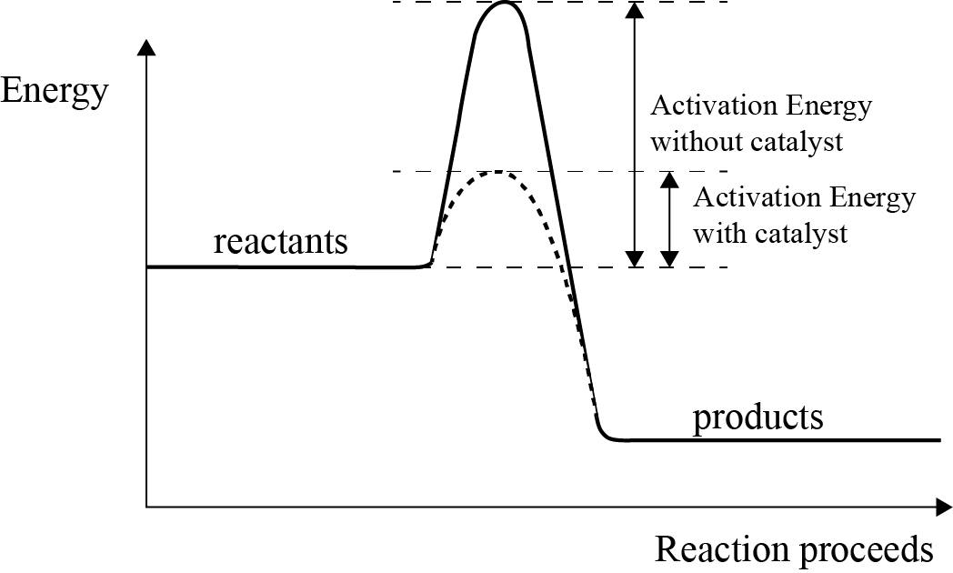
 |  |  |  |  |  | - An increase in temperature leads to increased E_{K} (energy) of the particles / faster moving particles.  OR  Increase in temperature leads to more collisions.  OR  Activation energy (E_{A}) is the energy required to start a reaction. |  |  | - Links temperature AND E_{K} (energy) / speed to the frequency (or number) of effective collisions AND activation energy (E_{A}). |  |  | - Compares the change in temperature and E_{K} in Experiment One and Experiment Two, and the effect on the reaction rate by linking this to effective particle collisions and activation energy (E_{A}).
(b) |  | In Experiment 2, the only change is an increase in temperature. An increase in temperature means an increase in the rate of reaction.  Increased temperature increases the speed of movement of the particles, and thus increases the frequency of collisions.  Increased temperature also increases the kinetic energy of the particles, so the collisions that occur are more likely to be successful (more likely to have sufficient activation energy). So the rate of reaction is increased.
(c) |  | In Experiment 3, the concentration of hydrogen peroxide has been increased. This will increase the rate of reaction because there are more hydrogen peroxide molecules per unit volume. This means there will be more frequent collisions in a given time due to having more reactant particles available to collide. This will increase the rate of decomposition of the hydrogen peroxide. |  |  |  | - Increase in concentration means more reactant particles per unit volume. |  |  | - Links change in the concentration to effective collisions and decomposition of peroxide (per unit volume). |  |  | - Compares concentration in Experiment 3 and Experiment 1 and the effect on reaction rate by linking to effective particle collisions.
 | NØ |  | N1 | N2 | A3 |  | A4 | M5 |  | M6 | E7 |  | E8
 | No response; no relevant evidence |  | 1a | 2a | 3a |  | 4a | 2m |  | 3m | 2e + 1m |  | 3e with minor error

Q | Evidence | Achievement | Achievement with Merit | Achievement with Excellence
TWO (a)(i) | Ammonia is basic, NH₃ + H₂O  NH₄⁺ + OH–.  When ammonia (partially) ionises in water, it produces hydroxide ions. (When hydroxide ions are in greater concentration than H₃O⁺, the pH will be above 7 and therefore basic.) | - Writes equation for ammonia in water. | - Links equation to explanation of ammonia being alkaline.
(ii) | Ammonia is a weak base, and so doesn’t ionise fully. This means that there are still many ammonia molecules in the reaction mixture with just some ammonium and hydroxide ions. Because all 3 species are present, the labels of ammonia or ammonium hydroxide are equally valid. | OR  Identifies NH₃ as a base. | OR  Explains that all species are present in the equilibrium mixture. | - Links ammonia as a weak base to ionisation (or dissociation / reaction)  AND  the presence of each reactant and product species in the equilibrium mixture.
(b) | HCO₃– + H₂O  CO₃^{2–} + H₃O⁺  HCO₃– + H₂O  H₂CO₃ + OH– | - Completes one equation.
(c)(i) | 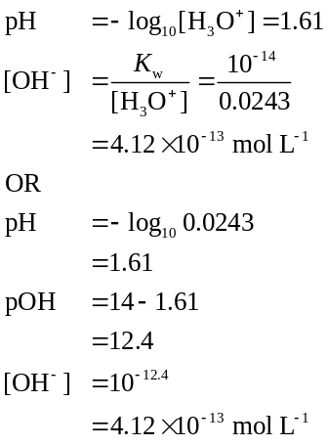 | - ONE correct calculation from (c)(i) and (c)(ii). | - TWO correct calculations from (c). | - ALL calculations correct in (c)(i) and (c)(ii) with units where applicable.
(ii) | [H₃O⁺] = 10^{–pH} = 10^{–11.8} = 1.58 × 10^{–12} mol L^{–1}  [OH–] = 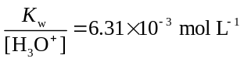
(d) | NH₄Cl is a better conductor of electricity because it completely dissolves / dissociates into ions:  NH₄Cl(s) → NH₄⁺(aq) + Cl–(aq)  (Then the NH₄⁺ ions react in water to produce hydronium ions, which makes it a weak acid:  NH₄⁺(aq) + H₂O()  NH₃(aq) + H₃O⁺(aq))  Ethanoic acid does not dissociate before reacting with water, so produces fewer ions than ammonium chloride, due to the formation of ions being dependent on the position of equilibrium, which for a weak acid like ethanoic acid, lies to the left, resulting in only a small number of ions being formed in this solution.  CH₃COOH(aq) + H₂O() ↔CH₃COO–(aq) + H₃O⁺(aq)  The ability to act as a conductor depends upon the concentration of ions. Ammonium chloride has a greater concentration of ions, so is a better conductor of electricity. | - Identifies the salt as the better conductor with a reason.  OR  Identifies ethanoic acid as the poorer conductor with a reason. | - Links dissociation to amount of ions present in NH₄Cl.  OR  Links CH₃COOH dissociation to its position of equilibrium or weak acid dissociation. | - Justifies determination that NH₄Cl is a better conductor than CH₃COOH using BOTH equations – one for NH₄Cl and CH₃COOH.
(e) | HCl is a strong acid because it fully dissociates in water.  HCl(aq) + H₂O() → H₃O⁺(aq) + Cl–(aq) [H₃O⁺] = 0.1mol L⁻¹  Whereas HCOOH is a weak acid, it does not readily dissociate in water.  HCOOH(aq) + H₂O()  H₃O⁺(aq) + HCOO–(aq)  [H₃O⁺] = 0.00398mol L^{–1}  In the resulting solutions, HCl has a higher concentration of H₃O⁺, and therefore a lower pH (1) than HCOOH, which has a lower concentration of H₃O⁺, and therefore a higher pH (2.4).  Both acids will react with the cleaned Mg ribbon, but with a higher concentration of H₃O⁺, HCl will have a faster rate of reaction with Mg than HCOOH, as there are more H₃O⁺ ions available to react in a given volume. | - Identifies methanoic acid as a weak acid.  OR  Identifies HCl as a strong acid.  OR  One [H₃O⁺] calculation.  OR  One equation with correct arrows. | - Links amount of H₃O⁺ / H⁺ ions to pH and the rate of reaction for ONE acid.  OR  Links amount of H⁺ / H₃O⁺ to pH or the reaction rate for both acids. | - Compares and contrasts the relative pH values in terms of the strength and the rate of reaction for BOTH acids.

NØ | N1 | N2 | A3 | A4 | M5 | M6 | E7 | E8
No response or no relevant evidence | 1a | 2a | 3a | 4a | 2m | 3m | 2e | 3e

Q | Evidence | Achievement | Achievement with Merit | Achievement with Excellence
THREE  (a) | A + 2B ↔ 3C + D | - Correct equation.
(b)(i) | Adding more ethanol causes the equilibrium to move in the forward direction in order to use the extra added ethanol. This is because the equilibrium has to re-establish itself with the added reactant in order to maintain K_{c}. | - Identifies reaction moving forward / right / products  - Catalyst speeds up the reaction.  OR  Equilibrium established faster.  - Correct K_{c} expression. | - Links addition of ethanol to equilibrium principles.  - Explains catalyst speeds up reaction, but does not favour either the forward or the reverse reaction. | - Explains the effect of changing concentration and catalyst on the equilibrium system in terms of relevant equilibrium principles.
(ii) | A catalyst speeds up the rate of the reaction so both forward and backward reaction will speed up but no particular reaction is favoured.
(c)(i) | 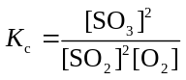
(ii) | 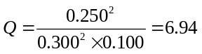  Since K_{c} = 4.32, Q ≠ K_{c}, so this reaction mixture is not at equilibrium.  This number is greater than the K_{c} value, 4.32, which indicates that the reaction lies to the products side as the larger the K_{c} or Q value, the greater the numerator (products). | - One correct step of the calculation. | - Correct calculation. | - Calculation correct and links to  Q ≠ K_{c} (4.32), or similar. (If correct, accept if something other than Q is used).
(iii) | At 450°C, the temperature has decreased. This reaction is exothermic, as shown by the negative enthalpy. This means that if the temperature is decreased, the reaction will move in the direction that produces more heat. Because this is an exothermic reaction, the exothermic direction is forwards. This will lead to more products and an increase in K_{c}. | - Identifies the forward reaction as exothermic OR  That the forward reaction is favoured / moves to right. | - Links reaction favoured to the production of heat / or increasing K_{c}. | - Explains the effect of decreasing temperature on K_{c}, in terms of relevant equilibrium principles and links this to product formation.

NØ | N1 | N2 | A3 | A4 | M5 | M6 | E7 | E8
No response or no relevant evidence | 1a | 2a | 3a | 4a | 3m | 4m | 2e | 3e

Cut Scores
Not Achieved | Achievement | Achievement with Merit | Achievement with Excellence
0 – 7 | 8 – 13 | 14 – 18 | 19 – 24

